**Beach Fires, Bike Tires, and Music Admirers**

**Regional Campout August 10 – 13, 2023**

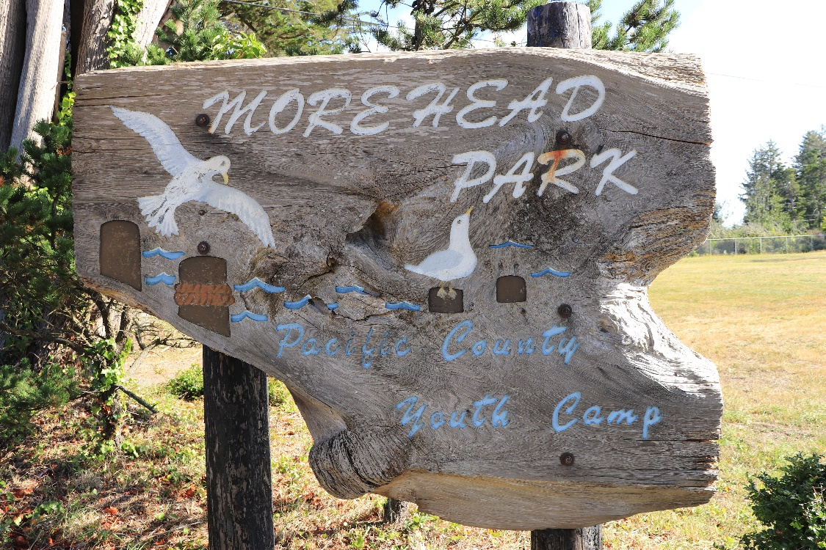**v**

We are again excited to host our 2023 Cascade Volcanoes Campout at Morehead Park in Ocean Park, Wa August 10 – 13, 2023. Our planning committee has been hard at work planning meals, outings, and activities.

Registration is $60 prior to AUGUST 1, 2023. After August 1, 2023registration is $75. Registration includes 3 nights of camping/cabins/tents and 3 dinner meals. Morehead Park is located on the Long Beach Peninsula. It includes 5 cabins with 2 sets of bunkbeds each, a kitchen with dining hall (no working appliances), restrooms with showers, access to the bay, a campfire pit, and a big, open field. This park is maintained by Pacific County Parks Department. Well-behaved dogs and their well-behaved human guests are welcome. Alcohol is allowed. BYOB. Our cancellation policy is: NO REFUNDS UNLESS YOU FIND YOUR OWN REPLACEMENT. NO EXCEPTIONS. Maximum limit of 25 attendees. The registration form is attached.

Address: 27600 Sandridge Rd, Long Beach, WA 98631 Website: <https://co.pacific.wa.us/parks/Morehead.html>

**ACTIVITIES:** There are lots of activities on the Long Beach Peninsula! Hikes, bikes, museums, and even a free summer concert at Waikiki Beach. Friday we will be heading down to the Oregon Coast for hikes and other activities. Saturday we will ride the Discovery Trail from Ilwaco to Long Beach and clean up beaches in Ilwaco for our stewardship event. *Old Growth Band*, featuring Hawaiian and American music with local ties to Clatsop and Pacific counties will provide musical entertainment on Saturday night. Sunday we will pack up and possibly explore more areas of the Long Beach Peninsula on our own.

**HIKES**:

-Kwis Kwis and Fort to Sea Loop 6.8 miles, 885 ft elevation, 3 hours within Lewis and Clark National Historic Park https://www.alltrails.com/explore/trail/us/oregon/kwis-kwis-and-fort-to-sea-loop

-Fort to Sea Trail, 6.1 miles, 534 ft elevation, 2 hrs 18 minutes through Lewis and Clark National Historic Park on to Sunset Beach. Shuttle is advised. <https://www.alltrails.com/explore/trail/us/oregon/fort-to-sea-trail>

-Battery Russel, Sunset and Kestral Trail Loop, 4.2 miles 95 ft elevation with beach access also within Fort Stevens State Park https://www.alltrails.com/explore/trail/us/oregon/battery-russel-sunset-and-kestrel-trail-loop

-Cathedral Tree Trail, 1.6 miles out and back 393 ft elevation. <https://www.alltrails.com/explore/trail/us/oregon/cathedral-tree-trail--2>

Don’t forget your bike or rent one here: Tsunami Bikes (601 Pacific Ave, Long Beach) Rentals are $10/hr or $40/day or ebikes $24/hr or $100/day.

**FOOD**: Thursday night meal will feature famous clam chowder from Mo’s followed by Friday night Taco Bar. Blackberry cobbler and s’mores will follow for dessert. Saturday will be our picnic at the concert with a selection of salads and breads.

**Questions**? Contact Rosanne@ [hudsonrosanne@gmail.com](mailto:hudsonrosanne@gmail.com) or [Lauriekerr@pacifier.com](mailto:Lauriekerr@pacifier.com)

If not currently signed, please complete the online liability/waiver <https://docs.google.com/forms/d/e/1FAIpQLSd8jH_DdM6lviz32oHqywEUCzU0GZW2P8LV_XeNBLNmnpj8bg/viewform>



**\*\*\*\*\*\*\*\*\*\*\*Please Detach and send only this page\*\*\*\*\*\*\*\*\*\*\*\*\*\*\*\*\*\*\***

**REGISTRATION FORM (Make Checks payable to Laurie Kerr)**

**Beach Fires, Bike Tires, and Music Admirers**

NAME_____________________________________________________

EMAIL_____________________________________________________

PHONE_____________________________________________________

ADDRESS__________________________________________________

EMERGENCY CONTACT NAME__________________________________

EMERGENCY PHONE_________________________________

Are you a Current Paid Member Yes No

Lodging Choices: Please list in order of preference: Write 1,2, or 3

Cabins_____________

Tent Camping____________

RV _________________

If you have special dietary needs, please bring what you need to add to our menu.

Circle days you are planning on eating dinner: Thursday Friday Saturday

Please send this completed form to Laurie Kerr with payment made out to Laurie Kerr at 11102 NE 196th St Battle Ground, Wa. 98604 before August 1st to get preregistration cost of $60. After August 1st the cost is $75. See you then!